**ML EXPERIMENT 11**

**import pandas as pd**

**from sklearn.decomposition import PCA**

**import matplotlib.pyplot as plt**

**# Load the dataset**

**column_names = [**

**"Class",**

**"Alcohol",**

**"Malic_Acid",**

**"Ash",**

**"Ash_Alcanity",**

**"Magnesium",**

**"Total_Phenols",**

**"Flavanoids",**

**"Nonflavanoid_Phenols",**

**"Proanthocyanins",**

**"Color_Intensity",**

**"Hue",**

**"OD280",**

**"Proline"**

**]**

**data = pd.read_csv("wine.data", names=column_names)**

**# Separate features (X) and target (y)**

**X = data.drop("Class", axis=1)**

**y = data["Class"]**

**# Perform PCA**

**pca = PCA(n_components=2)  # Reduce to 2 dimensions for visualization**

**X_pca = pca.fit_transform(X)**

**# Plot the PCA-reduced data**

**plt.figure(figsize=(10, 8))**

**plt.scatter(X_pca[:, 0], X_pca[:, 1], c=y, cmap='viridis')**

**plt.xlabel("Principal Component 1")**

**plt.ylabel("Principal Component 2")**

**plt.title("PCA on Wine Dataset")**

**plt.colorbar(label='Class')**

**plt.show()**

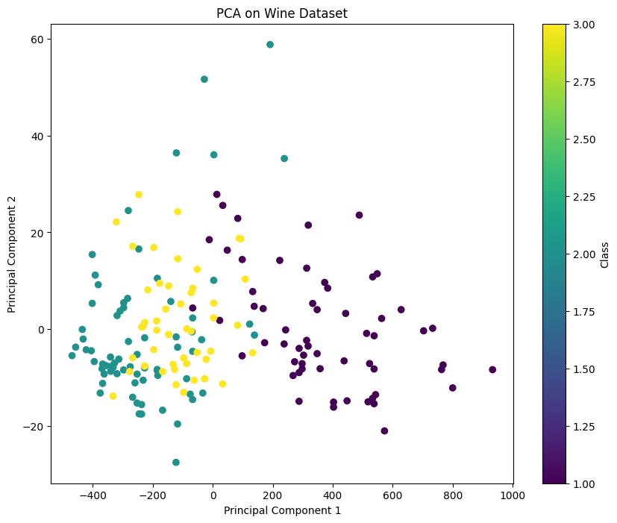

**# Add the transformed features back to the original DataFrame**

**data["PCA_Component_1"] = X_pca[:, 0]**

**data["PCA_Component_2"] = X_pca[:, 1]**

**# Display the new dataset**

**print(data.head())**

